**BWT WEEK 2**

**TASK 4**

**SHERAZ BIN TAHIR**

**MAIL:** [**BAIGS543@GMAIL.COM**](mailto:BAIGS543@GMAIL.COM)

**ALL ABOUT PYTHON 🐍**

**INTRODUCTION, SYNTAX, VARIABLES, CONDITIONS AND OPERATORS**

1. **Printing Hello**

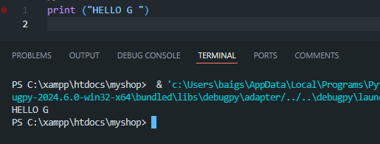

1. **Syntax**

In the case of Python, the syntax is too much simple. In other languages we use “;” to end a statement but in Python, we don’t use it.

To comment on a statement, we use “#” and for multiline comments, we use triple quotes """ or '''.

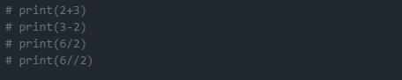

Syntax of conditions, functions, and operators is also totally different from other languages which we will discuss and practice along with these topics.

For input, we write **input()**. In parenthesis, we write anything related to the task we are performing.



1. **VARIABLES**

In python, we don’t need to declare variables, they are dynamically typed.

There are a few rules which need to be followed for naming a variable

* Start with a letter or underscore
* contain letters, numbers, and underscores
* Case-sensitive
* Avoid reserved keywords

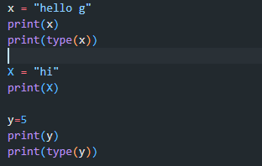

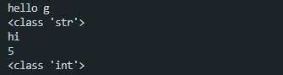

Here you can see, there is no declaration of variable. It’s also clear from datatypes.

X and x are declared separately and the output is also different (case sensitive).

1. **CONDITIONS**

The syntax of conditions in Python is as follows

**If – elif – else**

You can see this in the following code.

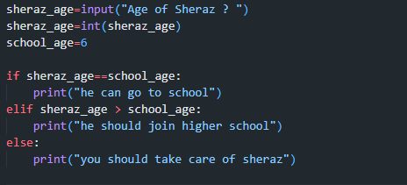

In other languages, we use else if but in Python we use elif.   
if one condition is fulfilled, a task related to that will be performed otherwise moving to the next.



1. **Operators**

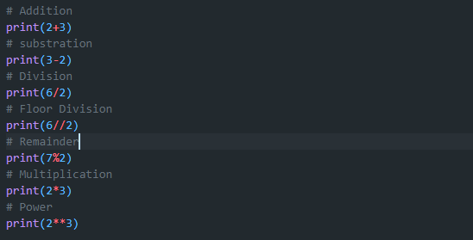

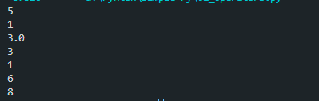

**Besides this, we also have comparison operators. ( ==, !=, >,<, =>, =< )**

